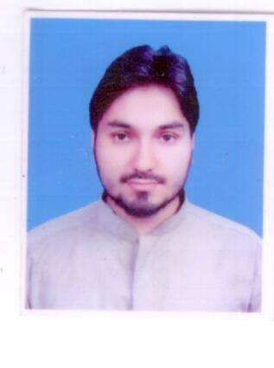 Mir Afzal

House# 30 Street# 03 Islamabad Homes Dhok Malyar Jhangi Saiydan

**Mobile:** 03439444072 **E-mail:** meer.balti@gmail.com

Objective

Seeking a responsible and challenging career with growth oriented organization where my skills and abilities may significantly contribute to the organization's growth and profitability.

Education

**2010 - 2014** BsCS COMSATS Institute of Information

**CGPA: 2.89** Technology, Abbottabad.

**2008 - 2010** ICS Public school and college Skardu.

**Grade achieved: 54.5%**

**2006 - 2008 SSC** Iqra Academy Abbottabad.

**Grade achieved: 75%**

Final Year Project

**Virtual Tour of COMSATS ABBOTTABAD campus, A 2D web based application.**

(Build using php framework)

**Skills**

**Technical:** Web development (php, HTML5, CSS3)

MySQL

**Others:**

1. WordPress
2. C/C++ Programming
3. C# Programming
4. ****Java Programing
5. Android Application Development
6. Image processing using Matlab
7. Packet tracer
8. Adobe Photoshop

**Hobbies and Interests**

Playing Football and Cricket also Internet surfing and book reading.

Reference

Mr. Sanaullah

SVP at Zarai Taraqiati Bank Limited.

Email : [svp.cod@ztbl.com.pk](mailto:svp.cod@ztbl.com.pk)

Phone Office : 0519252718